Task:1
Classification performance evaluation

To evaluate the classification performance I’m running the 5 algorithm of MultilayerPerceptron, Naive Bayes, J48, RandomForest, REPTree each with the 3 data set of breast-cancer.arff, diabetes.arff and iris.arff. For comparative analysis of the classification accuracy i need to evaluate each of every data-set classification rate. To do the thing, need to upload the data in weka.

MultilayerPerceptron classifier with breast-cancer.arff

Process:
Upload data: Preprocess -- Openfile -- Choose your data of format .arff -- open
Classification: Classify -- Classifier choose – weka -- classifier – functions – MultilayerPerception.
Test option: Cross validation choose fold 10 (default value for cross validation)
Run Classification: Run

In the classifier output it will show the summary results of classification.
We will look carefully about the Correctly classified instants. Here for MultilayerPerceptron classification of MultilayerPerceptron of breast-cancer.arff with default setting calculated the
classification accuracy with 64.6853% of 185 instances.

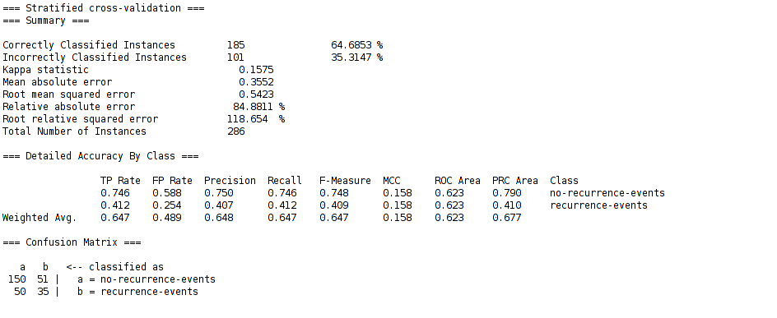
Figure Summary: In the above figure notice that 185 instants is correctly classified with accuracy of 64.6853 % and miss-classified instant is 101 of inaccuracy of 35.3147 %. The summary comes up with others significance terms along with confusion matrix.

In the classification output it will show details report with each and every attributes with it’s weights value. In the bottom of classification output it will come up with results of Kappa Statistic, Mean absolute error (MSE), Relative absolute error, Root relative square error (RSE), and details accuracy of the class with F-measure which is a very important for model selection. If your F-measure value is near to 1 then you can assume the created model is best. At the very bottom of the classifier output it will show the confusion matrix. Confusion matrix calculate the precision and re-col value of the model accuracy.

To get the classification error:
If you want to see the classification error for more details and want to make a plot with your custom x-label and y-lable. To change the x-label value just click and change the label just right click on the label.
Process: right click of your result list -- visualize classification error.

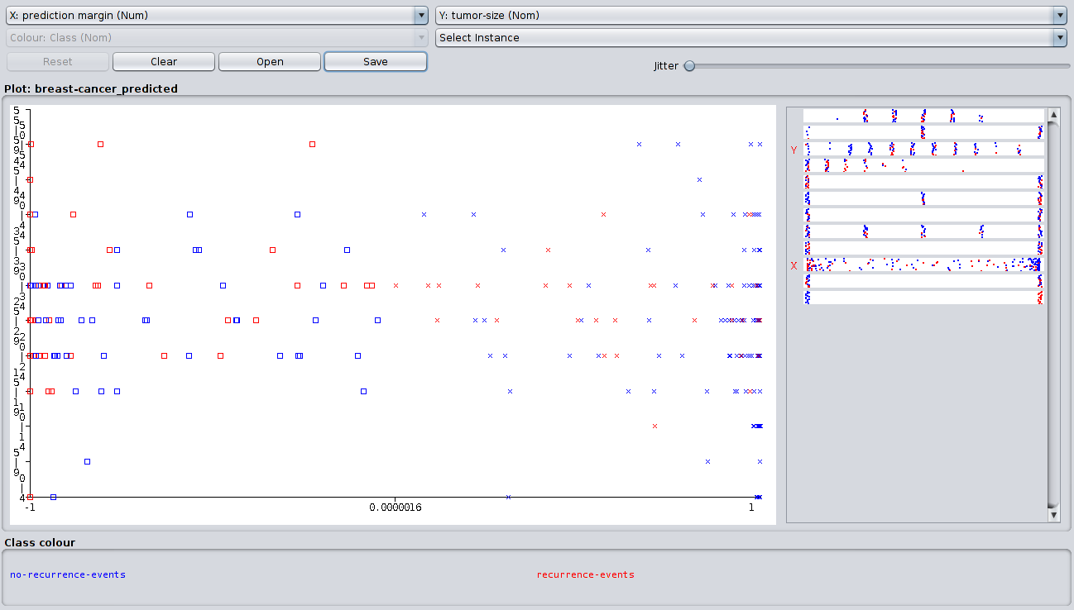
Figure Summary: The above figure is the classification error with x-label of prediction margin and y-label of tumor-size.

Visualization of data classification:
To visualize the classification go to visualizer it will plot a n*n dimensional visualization plot where n is the number of attributes.
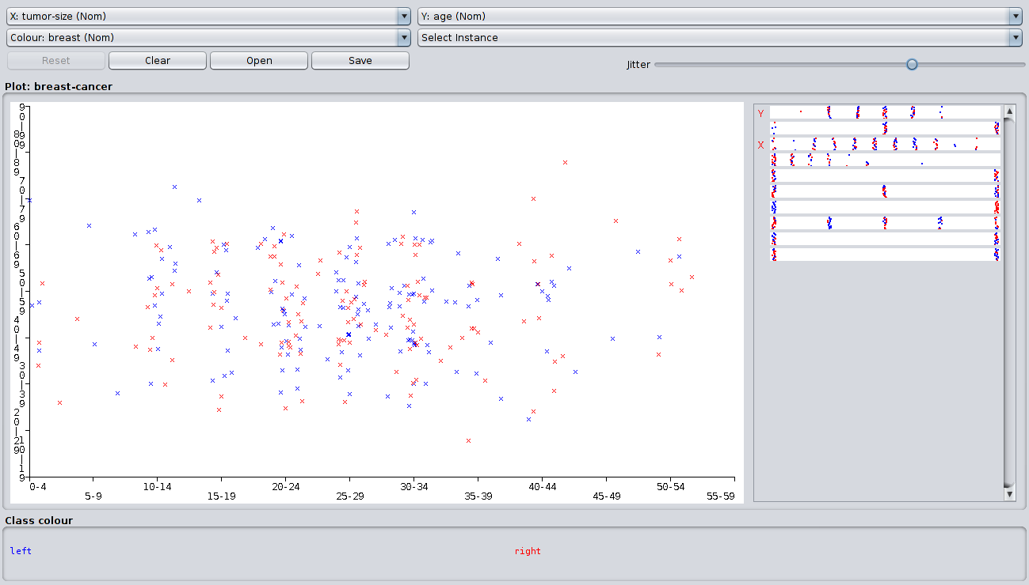
Figure summary: It’s the picture for classification of tumor-size in x-axis and Age in y-axis. Class color are define with two color of blue and red of shape x, one single type of color represent one class in the range of 0-60 of total 11 classes.
Classification accuracy table for 5 classification algorithm with 3 data set

 | Classification Algorithms
 | Multilayer  Perceptron | Naive Bayes | J48 | RandomForest | REPTree
breast-cancer.arff | 64.6853 | 71.6783 | 75.5245 | 69.5804 | 70.6294
diabetes.arff | 75.3906 | 76.3021 | 73.8281 | 75.7813 | 68.099
iris.arff | 97.3333 | 96 | 96 | 95.3333 | 94
Average | 237.4092 | 243.9804 | 245.3526 | 240.695 | 232.7284

From the above table we notice that breast-cancer data is giving best classification rate for J48 classification algorithm of 75.5245 % which is relatively good than others algorithms. Naive Bayes classification algorithm gives good results for diabetes data set and Multilayer Perceptron classification algorithm gives relatively good results for iris data set. Average classification rate for the five algorithm J48 classification algorithm gives relatively good rather than others then Naive Bayes algorithm buy REPTree not good for any of the data-set. So by comparing the classification performance we can draw a conclusion that REPTree is not so good for classification.

If we take a close look at the summary table for Multilayer Perceptron for breast-cancer the kappa statistic which adjust the error value of the error matrix in diagonally that value is 0.1575, for any good model this value will be close to zero.
Another error term is Mean absolute error which will calculate error in positive which value is 0.3552, for any good model it seems that this value will be close to zero.
Root mean square, Relative absolute error and Root relative absolute error is also calculating the error value but it has different meaning for each of the error term.

Now in the section of Details accuracy by class section is calculating performance for no-recurrence-events and recurrence-event. Here is the most important things is that F-measure value which is tell us about the model accuracy and how robust the model. Generally if the F-measure value is close to 1 then it suggest that the model is good enough which will give lower error and higher accuracy for classification . F-measure is calculating form Precision and Recall value.

Precision:
Precision means correctly distinguish the value from the testing data which is the summation of true positive and false negative.
Recall:
Recall means our model miss-classify the test data according to the given data-set. Recall is the summation of false positive and true negative.

F-measure is calculating from precision and recall using the formula

2 * Precision * Recall
F-measure = -------------------------------
Precision + Recall

Confusion matrix is known as a error matrix which will tell more about classification algorithm specially for supervised learning algorithm. In the confusion matrix each row is represent the predicted value and each column is represent the actual value. Where the first cell of first row call true positive, second cell called as false positive and second row of first cell called as true negative and second cell called as false negative.

